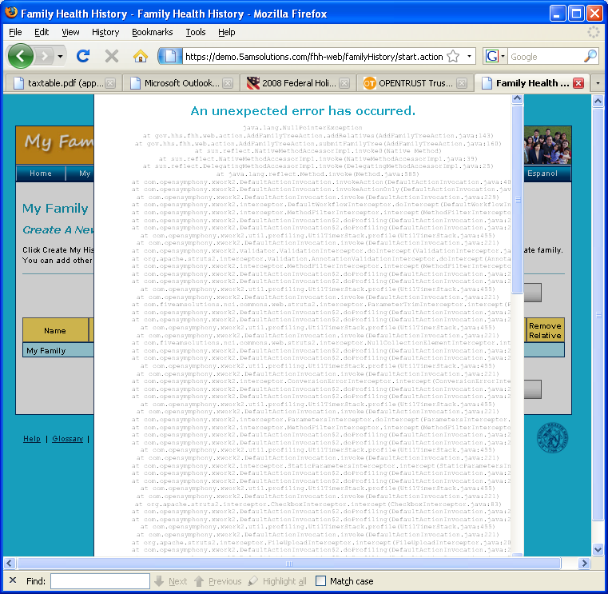

This error occurred upon striking the ‘build my family tree’ button on the build my family page. It may have been related to timing out on the site because I went to get lunch prior to completing the personal health information. Although the site did let me submit my personal information and then complete this submodal prior to throwing this error. I’m on firefox and XP.